Ideation Phase
Brainstorm & Idea Prioritization Template
Date | 8 October 2026
Team ID | SWTID-2026-3520
Project Name | Implement Client Script & UI Policy (Incident)
Maximum Marks | 4 Marks
Brainstorm & Idea Prioritization Template:
Brainstorming provides a free and open environment that encourages everyone within a team to participate in the creative thinking process that leads to problem solving. Prioritizing volume over value, out-of-the-box ideas are welcome and built upon, and all participants are encouraged to collaborate, helping each other develop a rich amount of creative solutions.
Use this template in your own brainstorming sessions so your team can unleash their imagination and start shaping concepts even if you're not sitting in the same room.
Step-1: Team Gathering, Collaboration and Select the Problem Statement
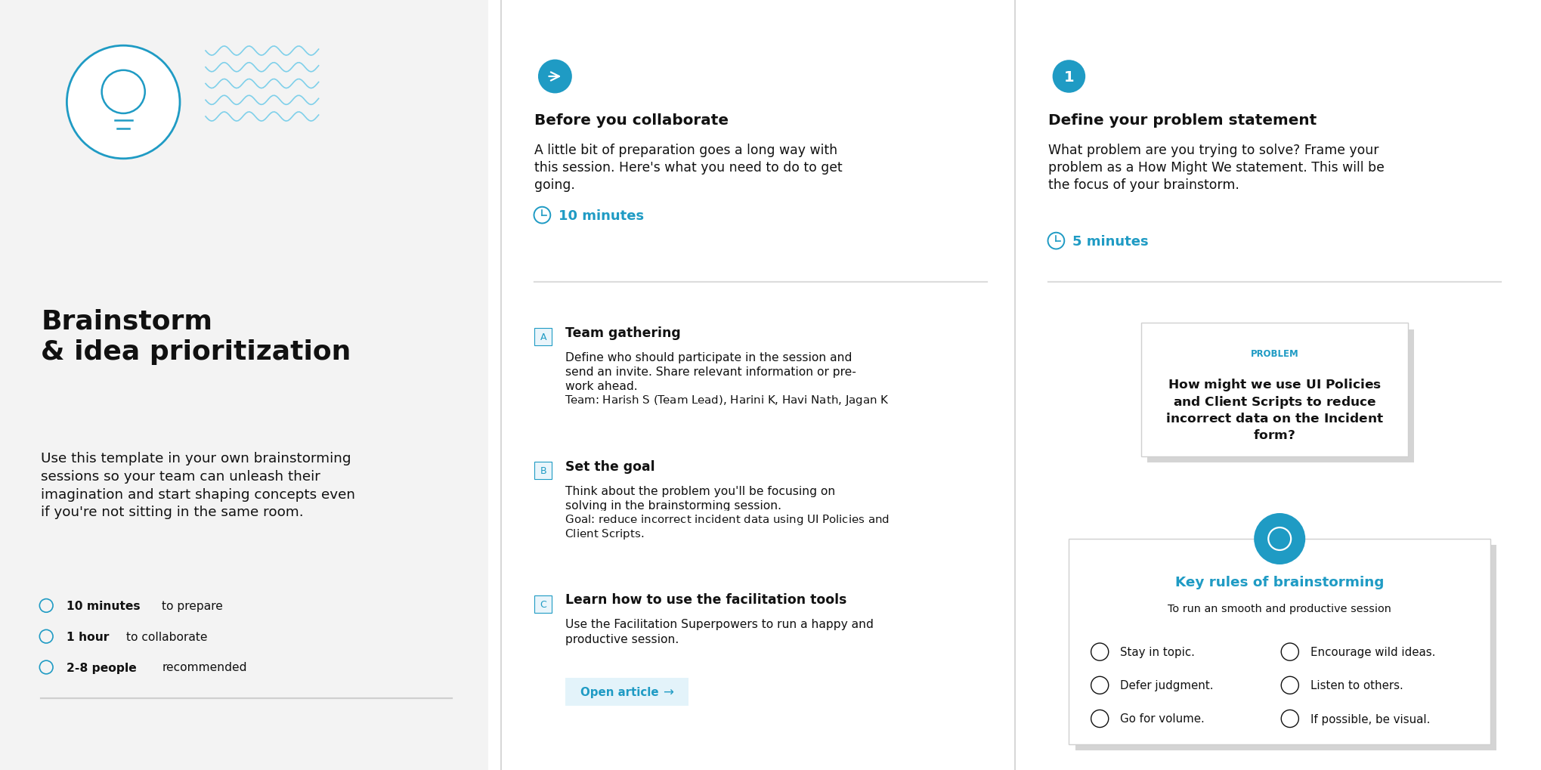

Step-2: Brainstorm, Idea Listing and Grouping
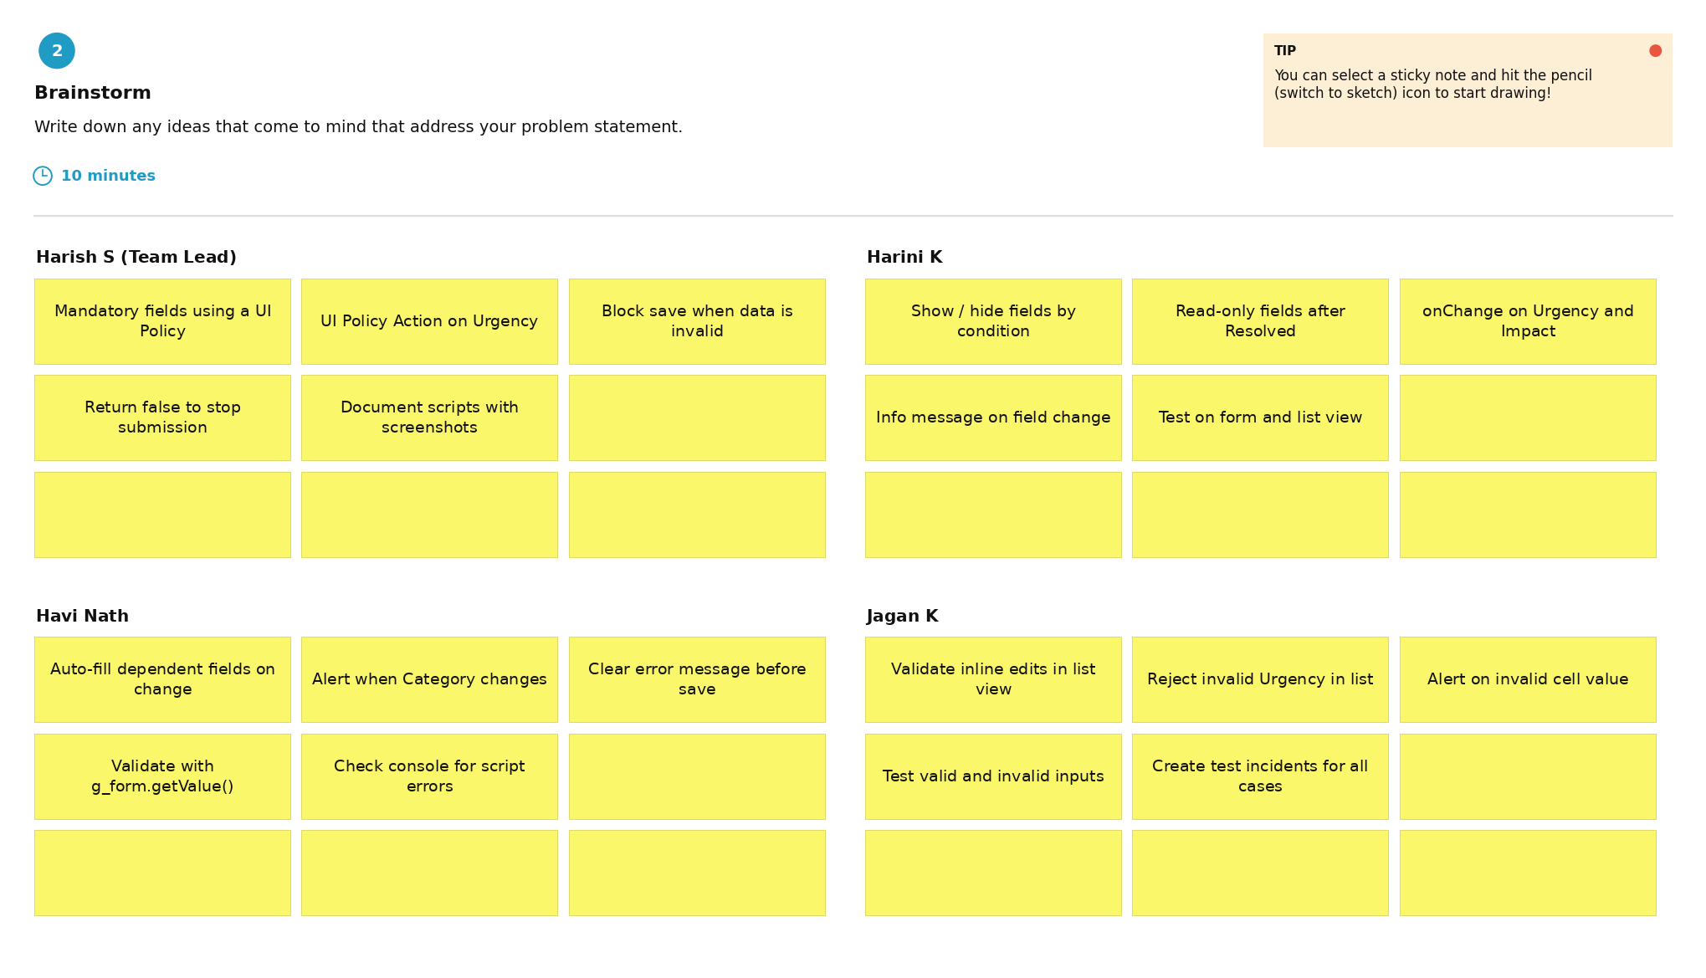

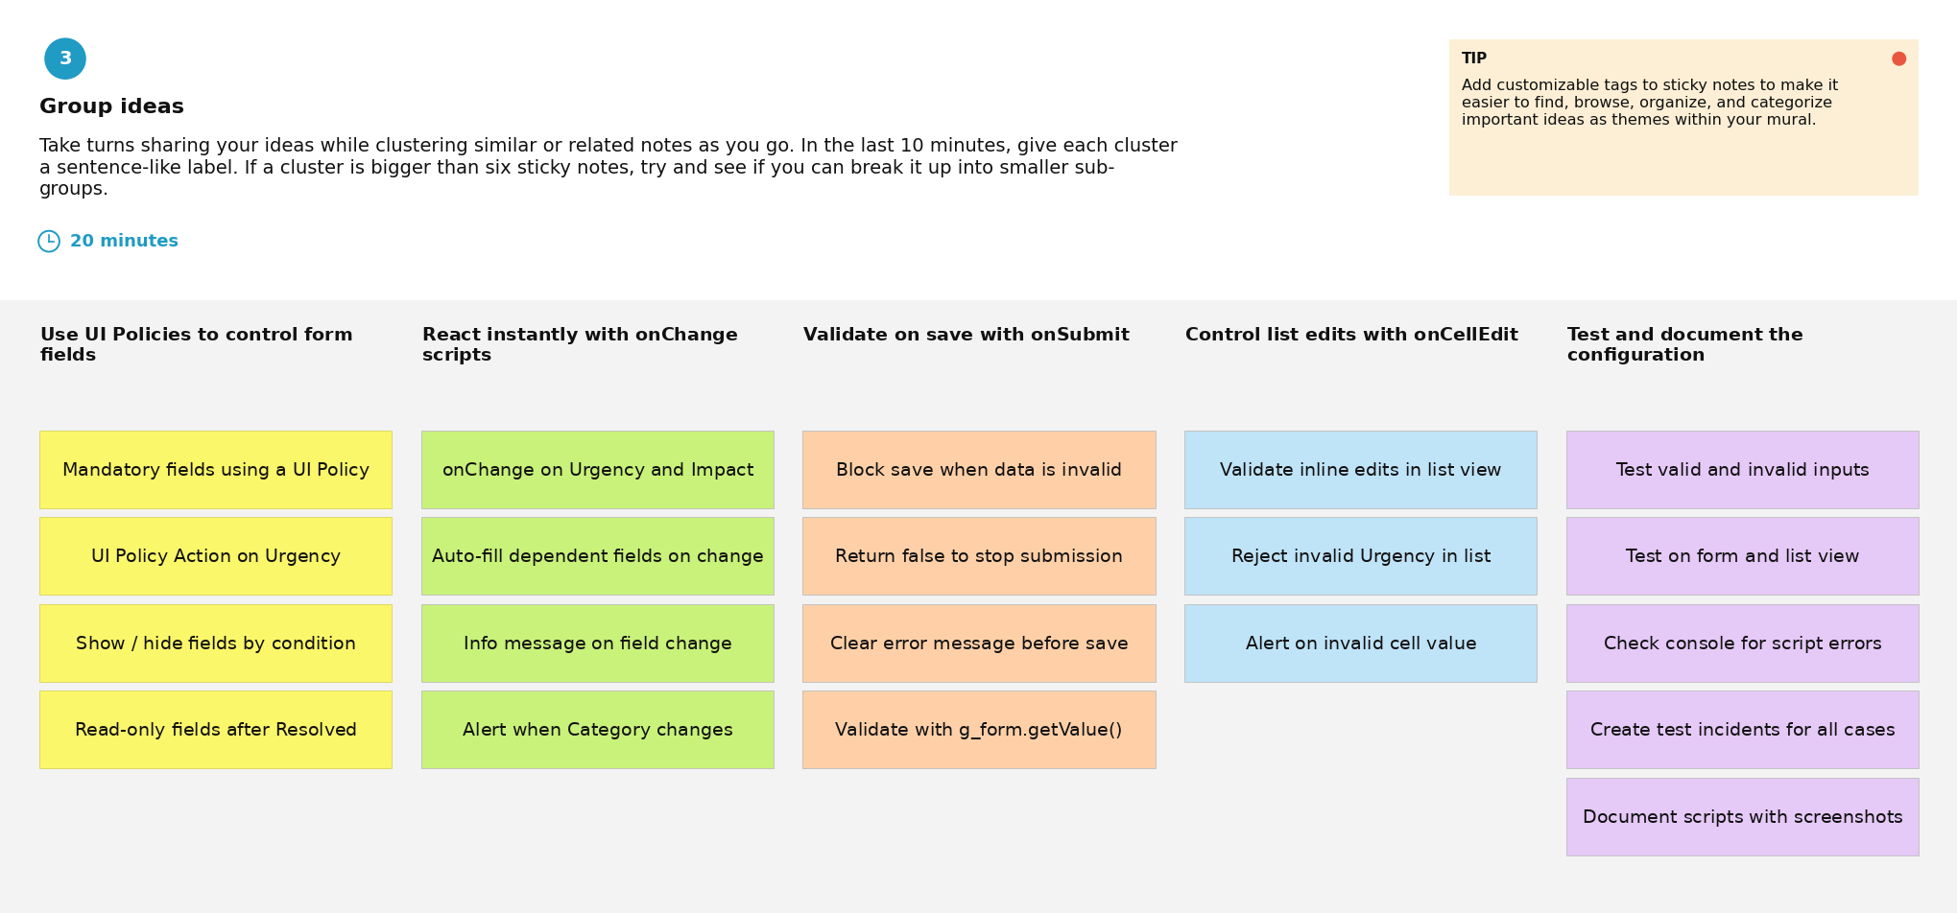

Step-3: Idea Prioritization
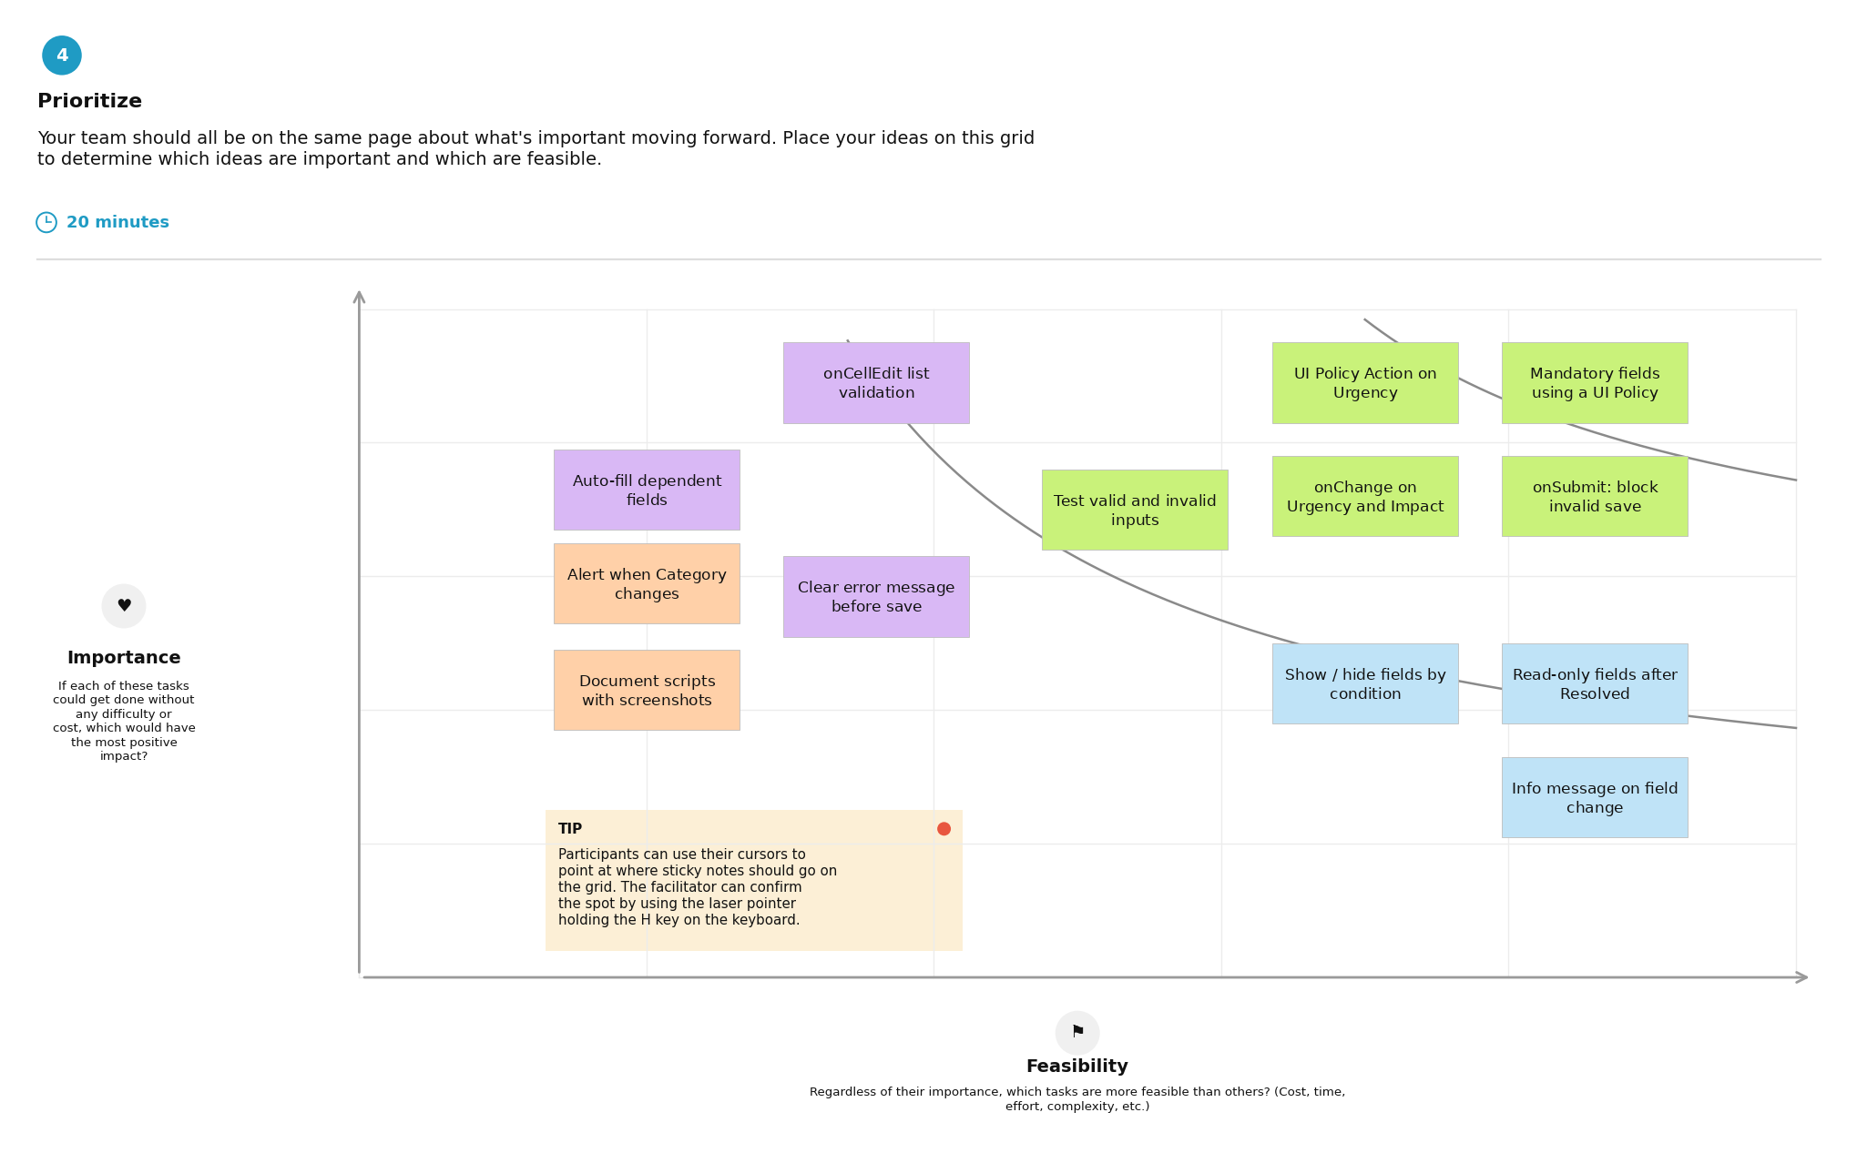
Sticky-note colours: green = high importance and high feasibility (do first); purple = high importance, lower feasibility (plan next); blue = lower importance, high feasibility (quick wins); orange = lower importance and feasibility (reconsider).

Project Task Assignment – Milestones

Milestone (Epic) | Task | Assigned to | Time | Level | Status
Milestone-1: Incident Form Configuration | Identify Incident fields and conditions | Havi Nath | 30m | Easy | Review
Milestone-2: UI Policy – Mandatory Fields | Configure UI Policy to make selected fields mandatory | Havi Nath | 45m | Easy | Review
Milestone-3: UI Policy – Read-only Fields | Configure UI Policy to make selected fields read-only | Jagan K | 45m | Easy | Review
Milestone-4: UI Policy – Visibility | Configure UI Policy to show/hide selected fields | Jagan K | 45m | Easy | Review
Milestone-5: Client Script | Implement dynamic Incident field behavior | Harini K | 1h | Medium | Review
Milestone-6: Testing & Validation | Test conditions, field behavior and user actions | Harini K | 1h | Medium | Review
Milestone-7: Conclusion | Document project outcome and verify consistent data entry | Harish S (Team Lead) | 30m | Easy | Review

